ENERGYM PROJECT

**LAUNCHING EC2-INSTANCES**

* Number of Instances – 2 [ 1.Jenkins server. 2.Docker server ]
* Applicationand OS images (Amazon machine image **) – UBUNTU**
* Select Ubuntu server 24.04 LTS (HVM), SSD volume type.
* Instance type – **T2 MEDIUM**
* Create a new key pair. (ppk file )
* Set up the VPC & SUBNETS – Default
* Create a new Security group
  + - Allow the SSH , HTTP & HTTPS
* Now adjust the storage(volumes) from 8Gb – 10Gb

Ref image

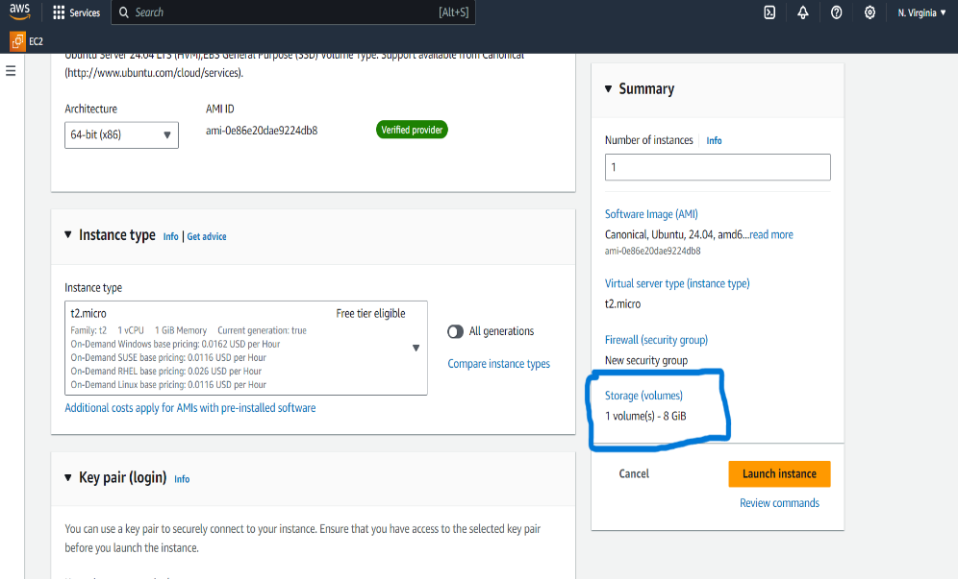

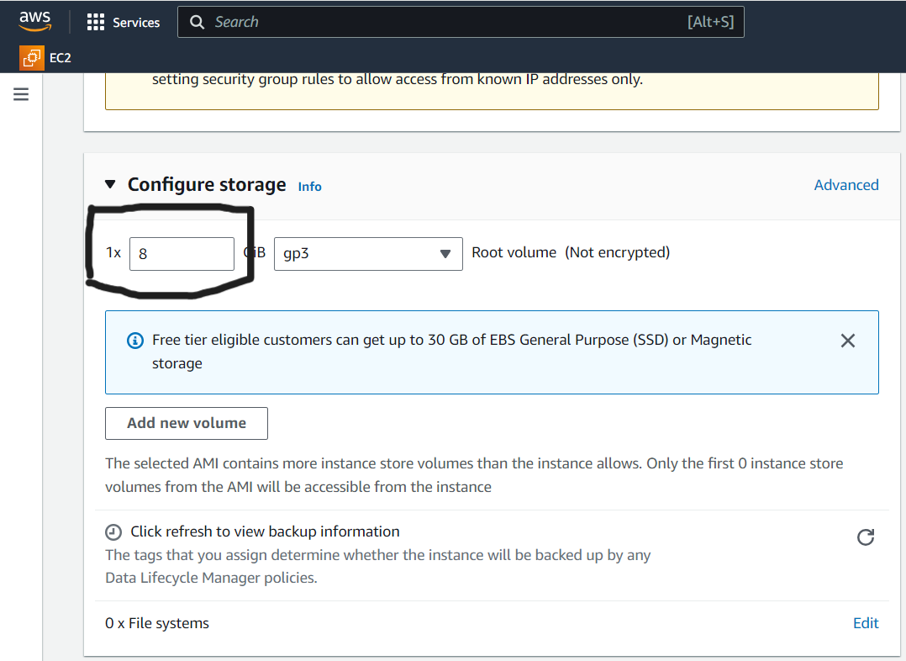

* **LAUNCH INSTANCE**
* **GO TO GOOGLE SEARCH BAR AND SEARCH FOR FREE CSS TEMPLATES**
  + - [**https://www.free-css.com/free-css-templates**](https://www.free-css.com/free-css-templates)
* Download any one CSS template and Extract file ( with WINRAR application)
* GO TO GIT HUB AND CREATE A NEW REPO

Ref image

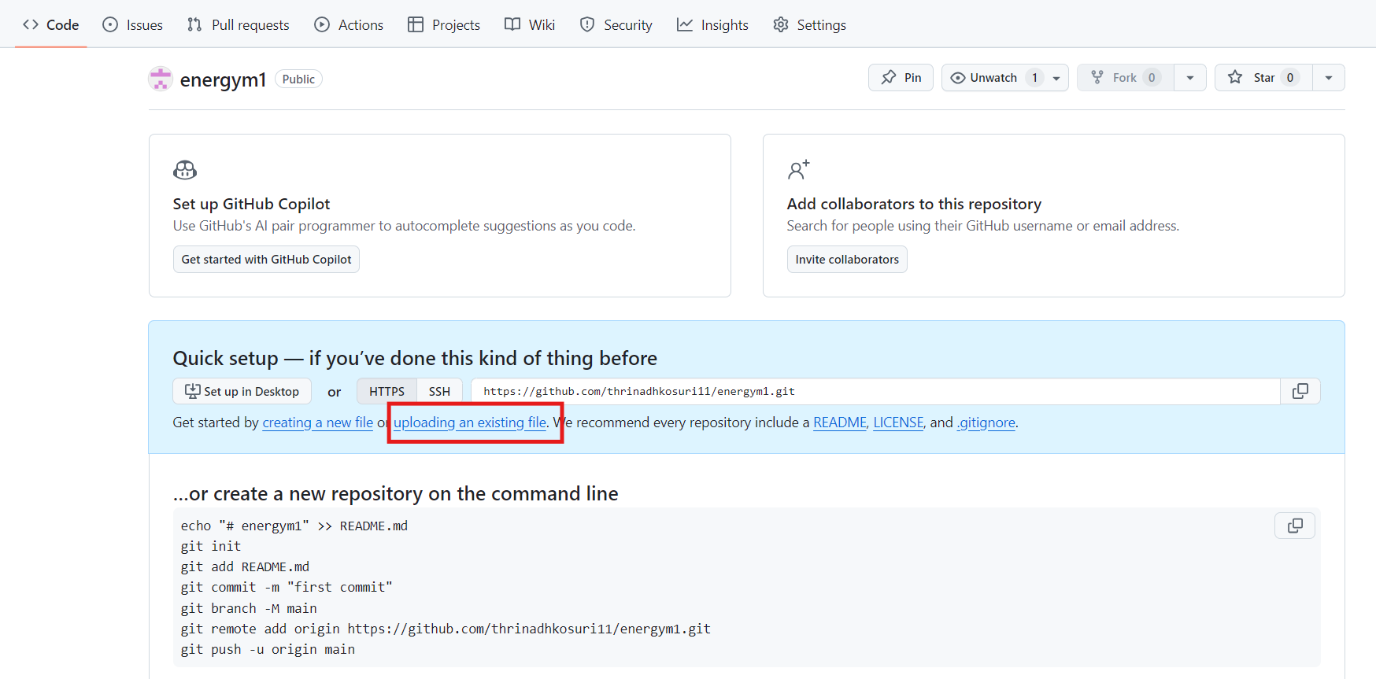

* Select UPLOADING AND EXISTING FILE
* Drag your downloaded CSS files into REPO
* COMMIT THE CHANGES
* Create a new Docker file in GitHub

Ref Image:

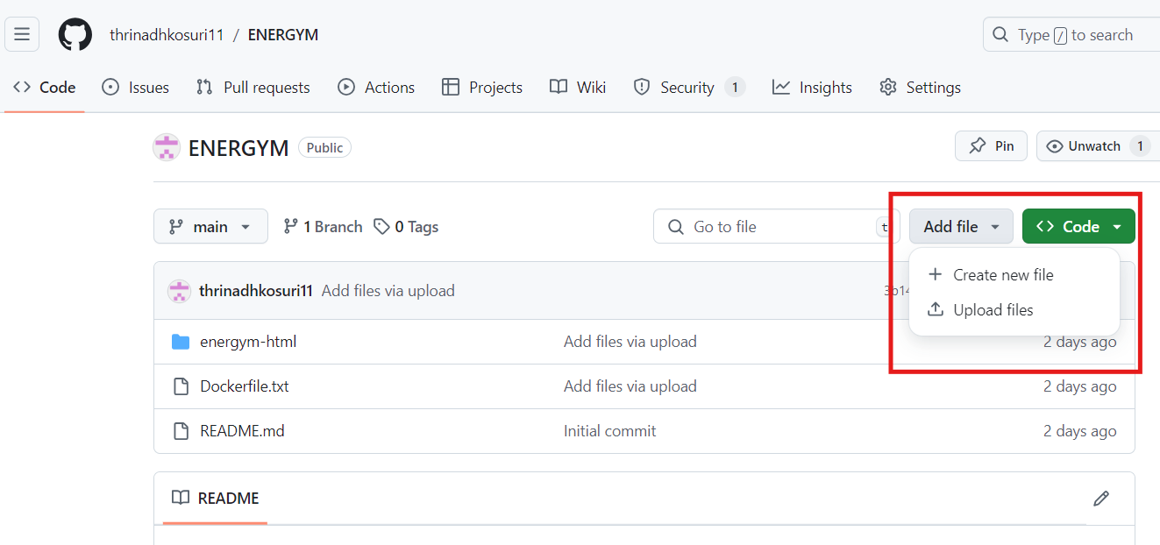

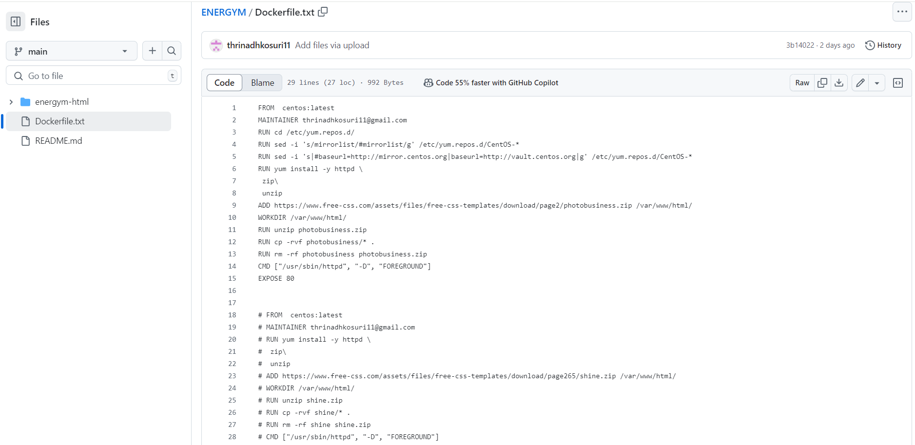

* COMMIT THE CHANGES
* Go to the Console and start the instances using putty and public IP address of servers

Ref Images:

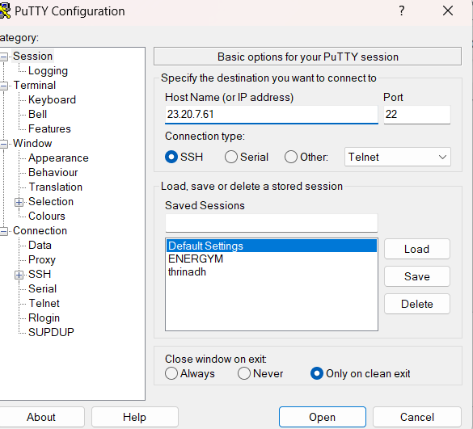

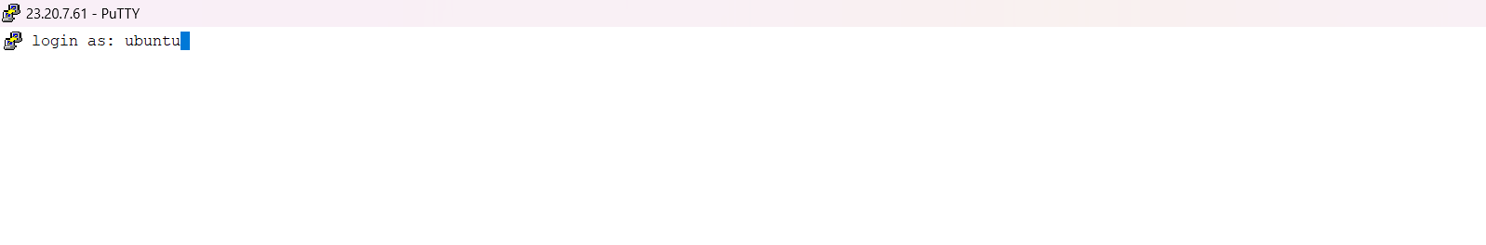

* **INSTALL THE JENKINS AND JAVA ON JENKINS SERVER(SERVER1)**
  + - [**https://www.jenkins.io/doc/book/installing/linux/#debianubuntu**](https://www.jenkins.io/doc/book/installing/linux/#debianubuntu)
* sudo wget -O /usr/share/keyrings/jenkins-keyring.asc \
* https://pkg.jenkins.io/debian-stable/jenkins.io-2023.key
* echo "deb [signed-by=/usr/share/keyrings/jenkins-keyring.asc]" \
* https://pkg.jenkins.io/debian-stable binary/ | sudo tee \
* /etc/apt/sources.list.d/jenkins.list > /dev/null
* sudo apt-get update
* sudo apt-get install Jenkins
* **INSTALLING THE JAVA**
* sudo apt update
* sudo apt install fontconfig openjdk-17-jre
* java -version
* openjdk version "17.0.8" 2023-07-18
* OpenJDK Runtime Environment (build 17.0.8+7-Debian-1deb12u1)
* OpenJDK 64-Bit Server VM (build 17.0.8+7-Debian-1deb12u1, mixed mode, sharing)
* sudo snap install openjdk

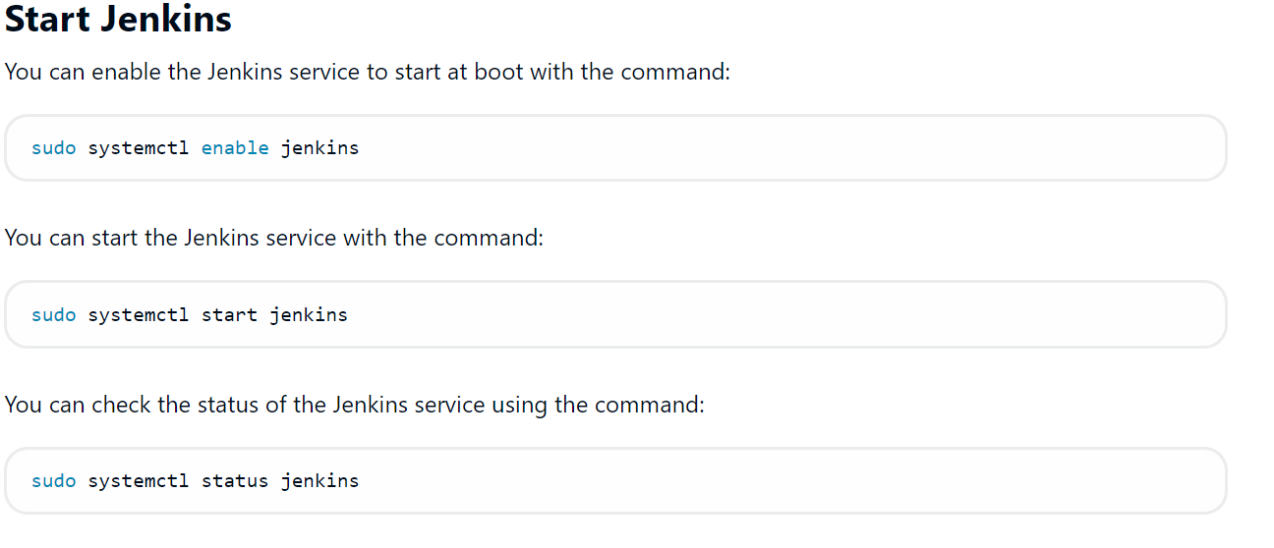

* In Inbound rules ADD NEW RULE Allow port range 8080

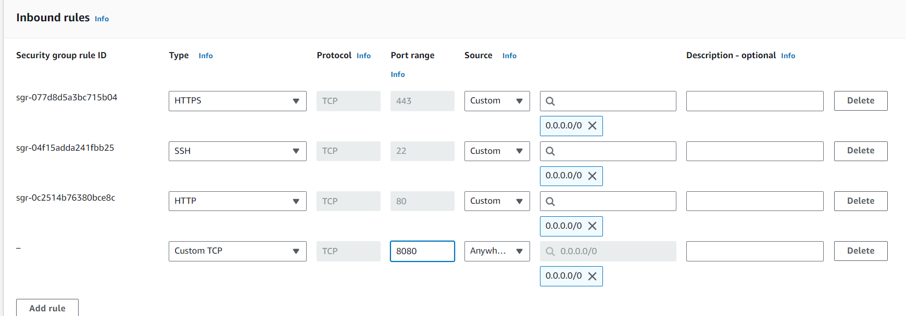

* Connect to the Jenkins Dashboard.
* **INTALL ANSIBLE IN JENKINS SERVER (SERVER1):**
  + - [**https://docs.ansible.com/ansible/latest/installation_guide/installation_distros.html#installing-ansible-on-ubuntu**](https://docs.ansible.com/ansible/latest/installation_guide/installation_distros.html#installing-ansible-on-ubuntu)
    - sudo apt update
    - sudo apt install software-properties-common
    - sudo add-apt-repository --yes --update ppa:ansible/ansible
    - sudo apt install ansible0ee22
    - sudo hostnamectl set-hostname jenkins
    - /bin/bash
    - sudo apt install python3-pip
    - pip install docker --break-system-packages
    - cd /etc/ansible
    - ls
    - sudo vim hosts

Ref Image:

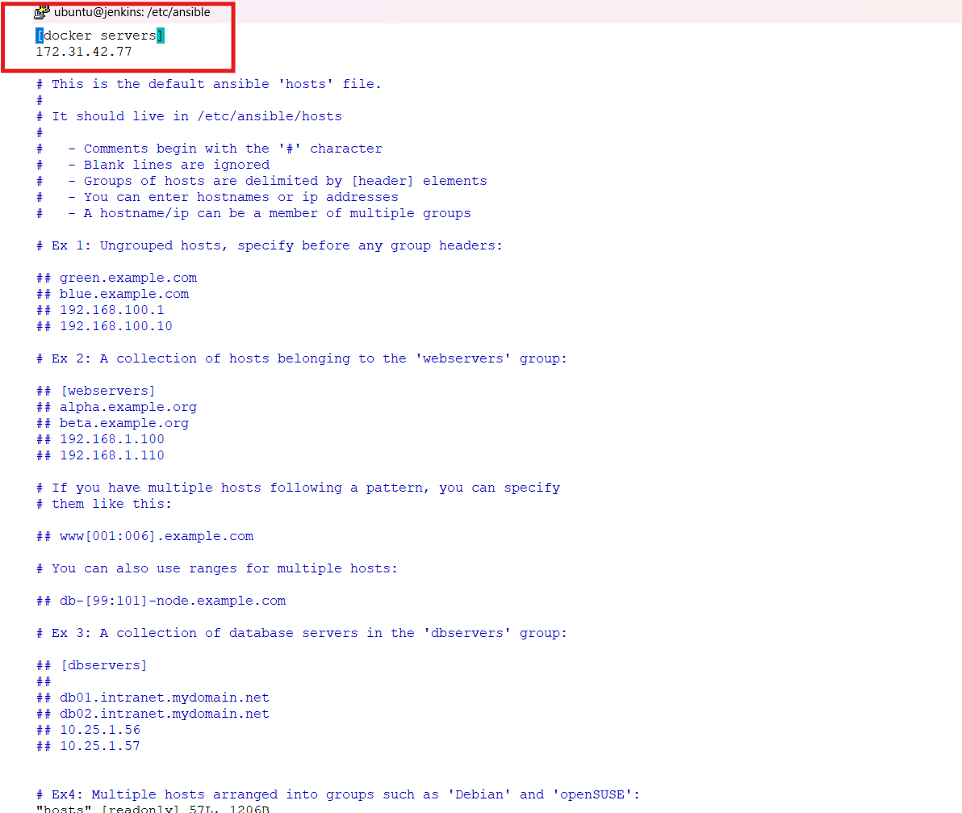

**NOTE :** Add the docker server private IP address as shown above and save the file.

* Save the changes wq!
  + - * ubuntu@172.31.46.63:/etc/ansible$ cd ~
      * ubuntu@172.31.46.63:~$ sudo hostnamectl set-hostname Jenkins
      * ubuntu@jenkins:~$ sudo su
      * ubuntu@jenkins:/home/ubuntu# su Jenkins
      * ubuntu@jenkins:/home/ubuntu$ cd ~
      * jenkins@jenkins:~$
      * mkdir playbooks
      * cd playbooks/
      * ssh-keygen

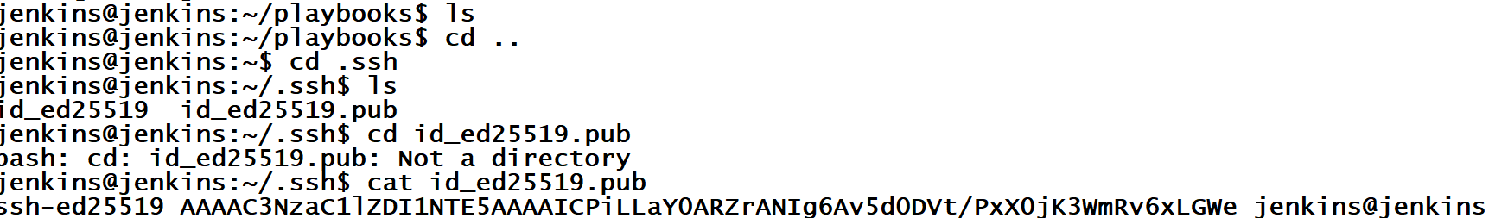

* + - GO TO SERVER 2 AND CONNECT AND INSTALL DOCKER
    - Sudo apt-get update
    - sudo apt-get install ca-certificates curl
    - sudo install -m 0755 -d /etc/apt/keyrings
    - sudo curl -fsSL https://download.docker.com/linux/ubuntu/gpg -o /etc/apt/keyrings/docker.asc
    - sudo chmod a+r /etc/apt/keyrings/docker.asc

# Add the repository to Apt sources:

* + - echo "deb [arch=$(dpkg --print-architecture) signed-by=/etc/apt/keyrings/docker.asc] https://download.docker.com/linux/ubuntu \ $(. /etc/os-release && echo "$VERSION_CODENAME") stable" | sudo tee /etc/apt/sources.list.d/docker.list > /dev/null
    - sudo apt-get update
    - sudo apt-get install docker-ce docker-ce-cli containerd.io docker-buildx-plugin docker-compose-plugin
    - docker ps
    - we get the error so called permissions denied
    - sudo usermod -aG docker ubuntu
    - newgrp docker
    - docker ps
    - sudo su
    - ssh-keygen
    - cd ~
    - ls –la
    - cd .ssh
    - ls
    - vim autherized-keys(need to comment and copy the ssh keyof jrenkins server to docker server)

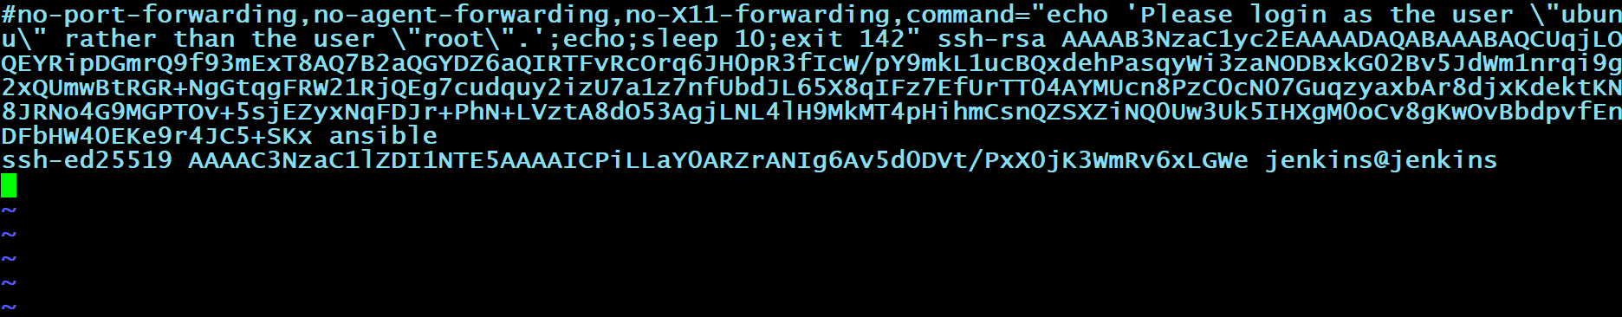

* + - sudo systemctl reload ssh
    - Go to Jenkins server and connect docker server from here
    - [jenkins@jenkins:~/.ssh$](mailto:jenkins@jenkins:~/.ssh$) ssh root@Public IP Address of Docker Server
    - exit
    - ls
    - cd ..
    - cd playbooks/
    - nano deployment .yaml

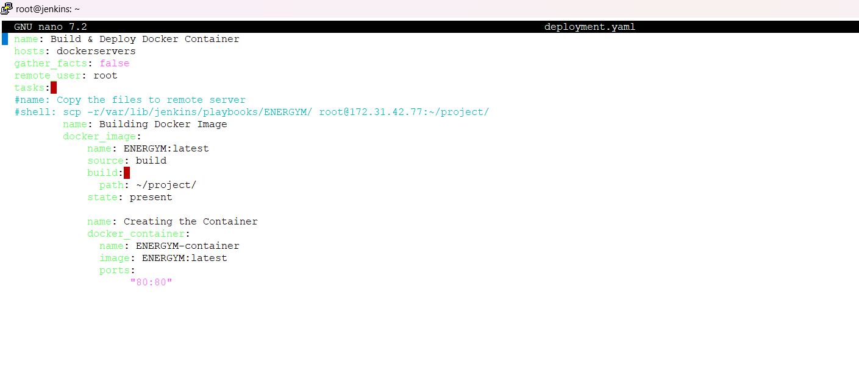

* + - * Save the file by clicking cntrl+x
      * Then Enter Y
      * After y entry then again ENTER . it will SAVE.
      * **GO TO THE JENKINS DASHBAORD**
      * Create a Free Style Project (ENERGYM).
      * Go to the source code Management

Ref Image:

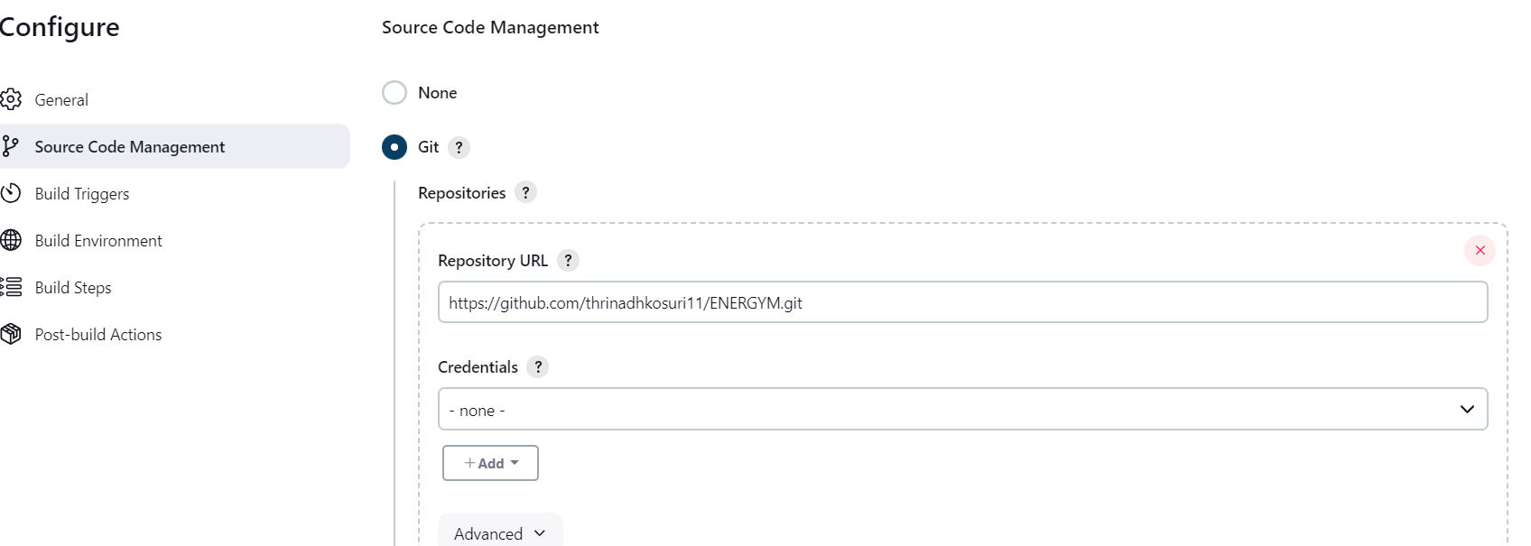

* + - Apply and Save
    - BUILD NOW
    - After your job successfully done . Go to the GitHub and Add Webhook

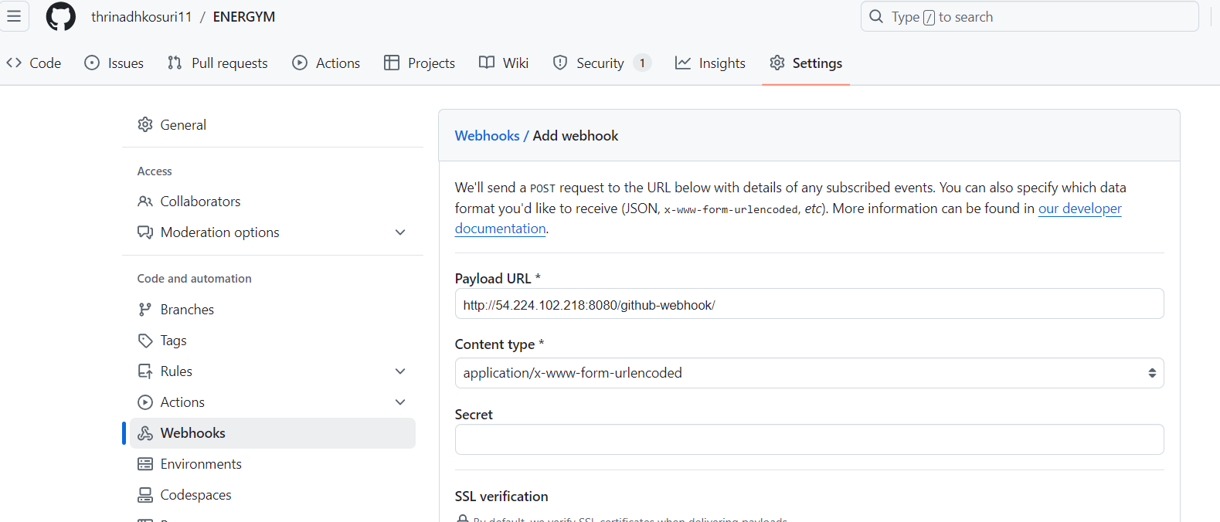

* + - Copy the Jenkins URL and paste in webhook as shown in the above image
    - Select Let me select individual events.
    - Select Pull Requests and Pushes

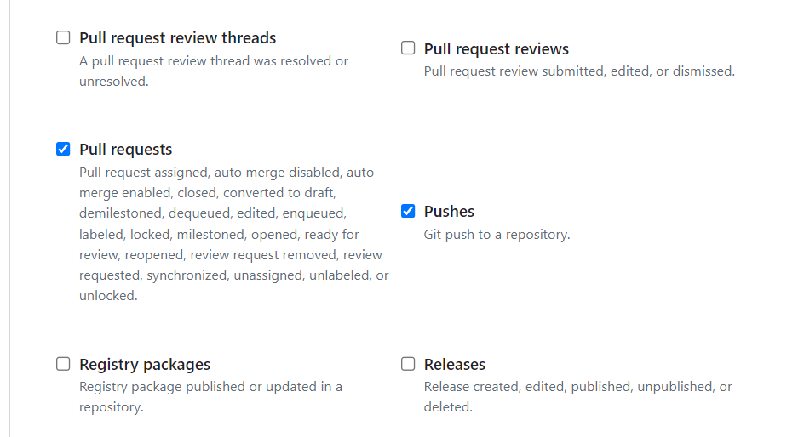

* + - Add webhook
    - Select build triggers – GitHub hook trigger for GITSCM polling
    - In GitHub go to your REPO codes and open your Docker File and make some changes and commit the changes

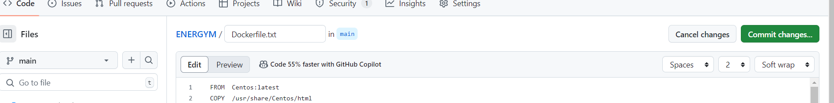

* + - Then, Go to the Jenkins Dashboard check that your project is automatically build or not. (Automatically build success)
    - Now, Go to the Docker Server instance terminal
    - Sudo su
    - cd ~
    - mkdir project

Ref Image:

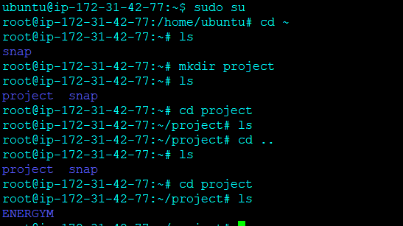

* + - Now, Go the Jenkins server instance terminal
    - jenkins@jenkins:~/playbooks$ scp -r /var/lib/jenkins/workspace/ENERGYM/ root@ 172.31.42.77:~/project/

NOTE: Private IP Address of the Docker server.

* + - Now, Go to the Docker Server instance terminal
    - Give the below commands as shown in the picture below

REF Image:

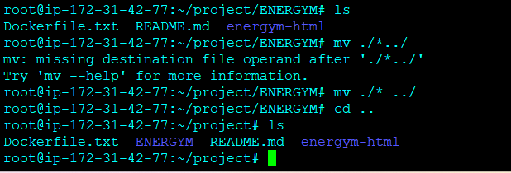

* + - Go to the Jenkins Instances Teriminal
    - Run the Command : ansible-playbook deployment.yaml
    - Go to the Jenkins portal
    - Go job configuration add Buildstep (Execute shell)

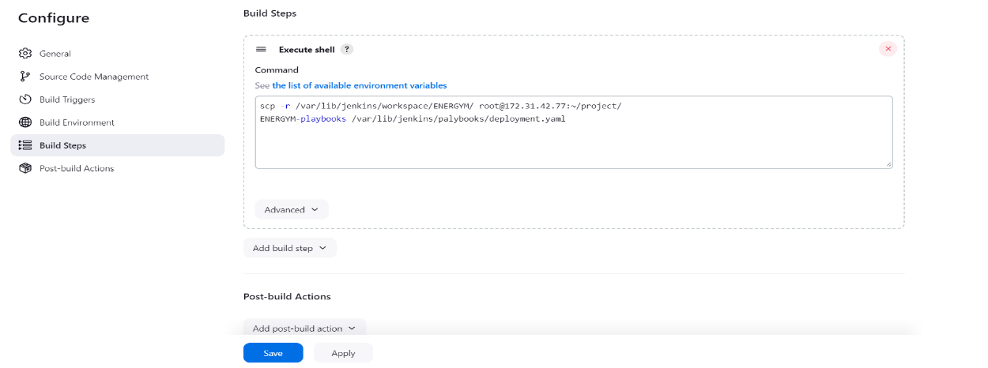

* + - Build now
    - Then check the console output
    - Now, copy the Public IP address of Docker Server and paste it in web to check your output

**OUTPUT:**

